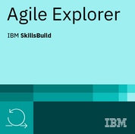**Agile Explorer**

**סילבוס:**

A taste of agile -

Agile Operation Fundamentals -

- Agile Program Fundamentals